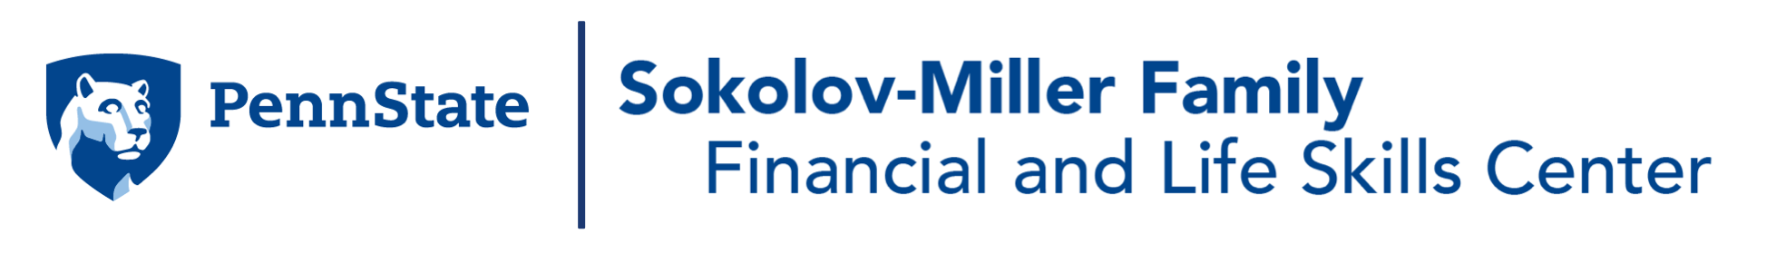
These resources were collected by the Sokolov-Miller Family Financial and Life Skills Center to help Penn State students make sound financial decisions whether to buy, rent, sell, keep new and/or old textbooks to support academic success and financial affordability. The Center offers 1-to-1 consultation to students to help them sort through and simplify this complex process. To schedule an appointment, choose option #2 on the Financial Literacy homepage.
We wish you success in your college experience.
-Financial and Life Skills Center Team

Resources for Buying New Textbooks
Website Name | Website Link | Description of resource and any additional info about resource
The Student Bookstore | The Student Bookstore | This will have a strong selection and prices will be slightly better than the Penn State Bookstore but prices will vary.
Amazon | Amazon | This will have a strong selection but may not have the most recent version or access codes but prices can be a bit cheaper.
Penn State Bookstore | PSU Bookstore | This will have the best selection but the highest prices for books.
Barnes and Noble | Barnes and Noble | They could have some books but definitely a last choice, although they may have better prices but low selection.

Resources for Buying Used Textbooks
Website Name | Website Link | Description of resource and any additional info about resource
Amazon | Amazon | Many textbooks have a “Used” option, however, most used books will not include an access code; prices can vary from as little as $10 to $200 depending on the subject, edition, and publisher of the textbook.
Barnes and Noble | Barnes and Noble | Many textbooks have a “Used” option, however, most used books will not include an access code; prices can vary from as little as $10 to $200 depending on the subject, edition, and publisher of the textbook.
Penn State Bookstore | PSU Bookstore | The Penn State bookstore should have all the textbooks you will need if the books are listed on the syllabus by the instructor. Compare to The Student Bookstore for pricing. Pricing may vary.
The Student Bookstore | The Student Bookstore | The Student Bookstore should have all the textbooks you will need if the books are listed on the syllabus by the instructor. Compare to The Student Bookstore for pricing. Pricing may vary.
Textbooks.com | Textbooks.com | Many textbooks have a “Used” option, however, most used books will not include an access code; popular GenEd/ETM classes sell out quickly, so there may be a better site for major classes
Ecampus.com | https://www.ecampus.com/cheap-textbooks | “Largest inventory of used textbooks”; used textbooks do not have access codes.
Chegg | https://www.chegg.com/used-textbooks | Save up to 90% on textbooks; 21-day risk free returns which are good if you drop or switch classes; 4 week free trial of Chegg Study; used textbooks may have highlighting but any textbooks with excessive markups will be taken out of circulation.
Abebooks | https://www.abebooks.com/?cm_mmc=msn-_-US_Brand-_-naa-_-naa&msclkid=a3bf24c41ec9166419f645b8321006c4 | Can buy or sell more than just textbooks (books, fine art, and collectibles). Is a subsidiary for Amazon. Marketplace--> independent sellers from over 50 countries.
Secondsale | https://www.secondsale.com/ | Only for buying used books or textbooks, 30 day return policy.
Biggerbooks.com | https://www.biggerbooks.com/buy-textbooks | Can rent, buy, or sell textbooks or ebooks. Comes with free shipping on orders over $59 and free return shipping. Can return purchases within 25 days.

Resources for Renting Textbooks
Website Name | Website Link | Description of resource and any additional info about resource
Penn State Bookstore | https://psu.bncollege.com/shop/psu/page/textbook-rentals | The Penn State Bookstore should have all the textbooks you will need as long as the books are listed on the syllabus by the instructor. Compare to The Student Bookstore for pricing. Pricing may vary.
The Student Bookstore | https://www.thestudentbookstore.com/rental-information | The Student Bookstore should have all the textbooks you will need as long as the books are listed on the syllabus by the instructor. Compare to the Penn State Bookstore for pricing. Pricing may vary.
Amazon | https://www.amazon.com/rentals/b?ie=UTF8&node=17853655011 | Amazon will rent out most textbooks. However, some books that may be used in smaller classes that aren’t textbooks may not be available to rent. They can be bought new or used. The process is similar to buying an item from Amazon. Search the item, choose the rental option, and follow the instructions for returning the item at the appropriate time. Prices may vary.
Barnes & Noble | https://www.barnesandnoble.com/h/terms-and-conditions/textbook-rentals | Similar to amazon, Barnes & Noble will rent out most textbooks. However, some books that may be used in smaller classes that aren’t textbooks may not be available to rent. They can be bought new, but not used. Prices may vary but buying books may cost more than renting.
Campus Book Rentals | https://www.campusbookrentals.com | Campus Book Rentals provides students with affordable textbooks and flexible rental periods. Shipping is free both ways; it is okay to highlight and write in the books, and you have access to live customer support. There is also a 21-day cushion to return books for a full refund.
eCampus.com | https://www.ecampus.com | Rental durations are flexible, with a choice between semester, quarter, or short term. Plus, you can extend your rental at any time. You can also return your purchase for any reason within 25 days. Take advantage of free shipping both ways on orders over $35. Additionally, there is often a live offer on their site that offers you a certain amount off (usually $5).
Chegg.com | https://www.chegg.com/ | You can rent textbooks or ebooks on Chegg with a 21-day risk free return policy for the duration of either quarter or semester periods. It comes with a prepaid return shipping label and free shipping for orders over $35. You get access to an ebook of the physical textbook with the order. However, if you need supplemental materials like an access code or lab manual, then you may need to purchase it separately or with a new textbook. Also, they let you highlight in the textbooks but no writing.  WARNING: Do NOT use Chegg study (which comes free for 4 weeks with orders) to cheat on exams.
CheapestTextbooks.com | https://www.cheapesttextbooks.com/ | Price comparison tool to find cheapest place to buy or rent new or used textbooks or ebooks. It also tells you the best places to sell back your textbooks if you already bought them. (It gives coupon codes available too.)
Knetbooks.com | https://www.knetbooks.com/ | Cheap place to rent textbooks that comes with free shipping on every order and a prepaid UPS return label. Multiple rental time options and extension or purchasing options if you want to keep the book longer.
Biggerbooks.com | https://www.biggerbooks.com/rent-textbooks | Can rent, buy, or sell textbooks or ebooks. Comes with free shipping on orders over $59 and free return shipping. Can choose what the rental term is (semester, quarter, or short-term-around 21 days) and can return purchases within 25 days.

Resources for Selling Textbooks
Website Name | Website Link | Description of resource and any additional info about resource
Barnes & Noble | https://www.barnesandnoble.com/textbook/textbook-buyback.jsp
Amazon | https://sell.amazon.com/learn/how-to-sell-books | Must create an Amazon Seller account to sell textbooks; do not need a large inventory.
Penn State Bookstore | https://psu.bncollege.com/shop/psu/page/sell-back-textbooks | Must have Penn State ID; only one copy of title per person.
Textbooks.com | https://www.textbooks.com/sell-textbooks.php?CSID=2CK2JDBOAZ3QCCDCK2M2CMSMS | Straightforward process and they provide shipping label. However, they do not buy back all textbooks.

Should you KEEP or SELL textbooks that are major-specific?
Keep | Sell
- It may be good to keep textbooks if you are taking exams external to PSU but specific for your career (examples: CPA, CFA, LSAT, NCLEX). | - It may be good to sell if you know you will not open the textbook again after the class ends.

Should you RENT or BUY textbooks for general required courses (GenEds, ETMs, etc.)?
Rent | Buy
- Cheaper  - Good idea if the class is not specific to your major  - Good idea if you are not necessarily too interested in the class and you are only taking it for the credit | - You most likely will need to buy an access code to complete assignments  - It may be better to buy physical textbooks if you cannot focus while reading digital textbooks

Other Tips/ Advice / Suggestions
- Wait to see if you NEED the book or if it just SAYS it is required (check rate my prof, ask others you know who took the class, ask the instructor; some will be honest and say it is not required).
- Check Amazon, off-campus student bookstore, Barnes and Noble (online), BEFORE the on-campus bookstore.
- On the page for your class schedule, there will be a link for your textbooks. The link will send you to the Penn State Bookstore website where it will list out all the materials for each class in your schedule. If there are no textbooks listed at the time, you will need to keep checking this page in case there is an update.
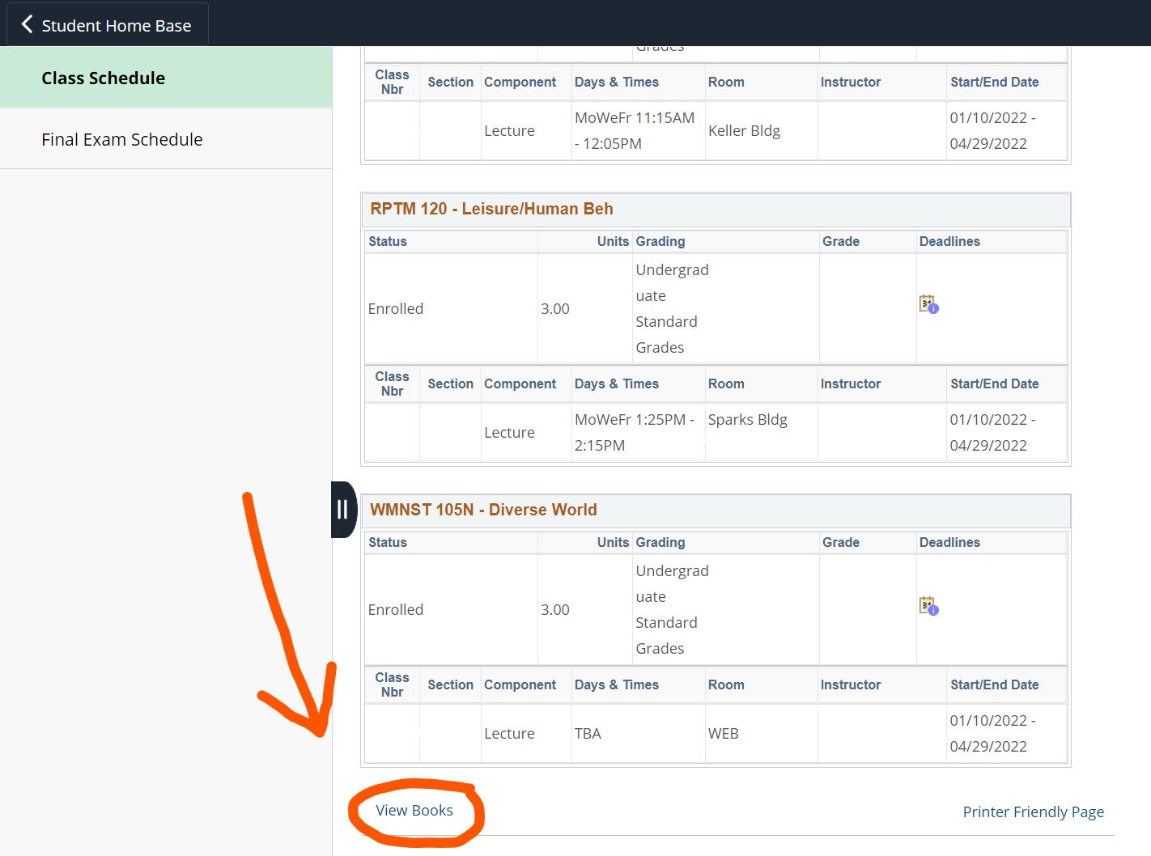
- Only get a used textbook if you do not need to do homework through a platform (McGraw Hill, Cengage, etc.) but you still want a physical copy of the book.
- Each website/platform will most likely have a Buy new, Buy used, Rent, and Sell option; however, the price between these websites/platforms will vary depending on the textbook.

